PROJECT REPORT

GAMIFIED ASSESSMENTS PRACTICE PLATFORM
(GAPP)

Submitted for the partial fulfillment of award of
BACHELOR OF TECHNOLOGY
In
Computer Science & Engineering
By
Shashikant Chaubey (2000300100207)
Shaurya Tyagi (2000300100208)

Under The Guidance & Supervision of
Dr. Shweta Chaku Ma’am


Inderprastha Engineering College, Ghaziabad
Dr. APJ ABDUL KALAM TECHNICAL UNIVERSITY
LUCKNOW
Dec 2023

Certificate

Certified that SHASHIKANT CHAUBEY and SHAURYA TYAGI has carried out the project work presented in this report entitled “GAMIFIED ASSESSMENTS." for the award of Bachelor of Technology from Inderprastha Engineering College, Ghaziabad, under my supervision. The report embodies result of original work and studies carried out by Student himself and the contents of the report do not form the basis for the award of any other degree to the candidate or to anybody else.

Shweta Chaku Ma'am
(Associate Professor)
Address: Inderprastha Engineering college

Date:

Acknowledgement

We take this opportunity to thank our teachers and friends who helped us throughout the project.

First and foremost, I would like to thank my guide for the project (Shweta Chaku ma'am, assistant professor, Computer science department) for her/his valuable advice and time during development of project.

We would also like to thank Dr. Vijai Singh (HOD, Computer Science Department) for his constant support during the development of the project.

Shashikant Chaubey Shaurya Tyagi
2000300100207 2000300100208

Declaration

I hereby declare that this submission is my own work and that, to the best of my knowledge and belief, it contains no material previously published or written by another person nor material which to a substantial extent has been accepted for the award of any other degree or diploma of the university or other institute of higher learning, except where due acknowledgment has been made in the text.

Signature:
Name: Shashikant Chaubey Name: Shaurya Tyagi
Roll No.: 2000300100207 Roll No: 2000300100208

Date: 23-12-23

ABSTRACT

This project introduces a novel solution to address the growing need for effective and engaging ways for students to practice questions related to gamified assessments. Traditional assessment methods often lack the interactive and dynamic elements that can capture students' attention and foster a deeper understanding of the subject matter. Our proposed platform combines the principles of gamification with educational assessment, creating an immersive and enjoyable environment for students to practice and reinforce their knowledge.
The Gamified Assessment Practice Platform (GAPP) incorporates elements such as game-based scenarios, interactive quizzes, and real-time feedback to make the learning experience both challenging and entertaining. Through carefully designed levels, students’ progress through different difficulty tiers, allowing for a gradual and adaptive learning curve. The platform also includes a diverse range of question formats, ensuring that students develop a comprehensive understanding of the material and are well-prepared for various assessment styles.
Key features of GAPP include a user-friendly interface, detailed performance analytics, and a leaderboard system to encourage healthy competition among students. The platform is accessible across multiple devices, fostering flexibility in learning and accommodating diverse learning styles. Additionally, GAPP promotes collaborative learning through interactive challenges and group activities, creating a sense of community among users.
The implementation of GAPP aims to enhance students' engagement, motivation, and knowledge retention by transforming the often-mundane process of assessment preparation into an enjoyable and rewarding experience. By combining the excitement of gaming with the rigor of educational assessment, GAPP strives to contribute to improved academic outcomes and a positive shift in students' attitudes towards learning.

    - TABLE OF CONTENTS

CHAPTER NO. TITLE PAGE NO.

ABSTRACT iii
LIST OF TABLES xvi
LIST OF FIGURES xviii
LIST OF SYMBOLS, ABBREVIATIONS xxviii

- INTRODUCTION Page No
1.1 Problem Definition
1.2 Background about the project idea
1.3 Objectives of proposed system
1.4 Feasibility Study, need and significance
1.5 Novelty of Project
1.6 Technical Specification
1.5.1Hardware and Software requirements
2. LITERATURE REVIEW
2.1 Existing System - Theoretical and methodological contributions to a particular topic of scholarly papers/ articles /books
3. PROPOSED SYSTEM
4. SOFTWARE REQUIREMENT ANALYSIS
4.1. Functional Requirements
- Use Case diagram with proper factoring
- Use case descriptions
4.2. Nonfunctional Requirements
4.3. Major Modules and their functionalities
5. SYSTEM ANALYSIS & DESIGN
5.1 Class designs (Wherever applicable)
5.2 Sequence diagrams
5.3 Activity Diagrams
5.4 DFDs of the project
5.5 Database Design
5.5.1 E-R Diagrams
5.6 Gantt Chart & Pert Chart (Wherever applicable)
6. IMPLEMENTATION/CORE MODULE
6.1 Tables – explaining all fields and their data types for data base used in project.
6.2 Used Algorithms/Approaches for projects.
6.3 Implementation of Modules/Algorithms.

7. RESULTS / OUTPUTS & TESTING
7.1 All user interfaces and output screens
7.2 Design and Test Steps / Criteria
7.3 Testing Process

8. REFERENCES

      - Introduction

1.1 Problem Definition

In the realm of education, conventional assessment practices often face significant challenges that impact the overall learning experience for students and educators. Traditional assessments are commonly perceived as static, lacking in engagement, personalization, and timely feedback. These shortcomings contribute to disengagement, hinder adaptive learning strategies, and limit educators' ability to make informed instructional decisions based on real-time data.
Challenges:
- Engagement Deficiency:
  - Traditional assessments can be perceived as monotonous, leading to reduced student engagement and motivation.
  - Lack of interactive and stimulating elements hampers the overall enjoyment of the learning process.
- Adaptability and Personalization:
  - Existing assessment systems often fail to adapt to diverse learning styles and preferences, providing a one-size-fits-all approach.
  - The absence of personalized assessments may hinder students' ability to maximize their learning potential.
- Feedback Limitations:
  - Timely and constructive feedback is essential for student growth, yet conventional assessment practices may struggle to provide detailed and timely feedback.
  - A lack of actionable feedback impedes students' understanding of their performance and areas for improvement.
- Maintaining Exam Integrity:
- Traditional assessment methods may face challenges in maintaining the integrity of exams, with possibilities of cheating or unauthorized assistance.
- The lack of robust mechanisms to ensure exam integrity can compromise the reliability of assessment outcomes

.

1.2 Background of the Proposed Idea.

In the ever-evolving landscape of education, the integration of technology has become a catalyst for transformative learning experiences. Recognizing the need for a paradigm shift in how students engage with assessment materials, our project introduces the Gamified Assessment Practice Platform (GAPP). GAPP stands at the intersection of education and gamification, pioneering a novel approach to assessment preparation that transcends traditional methods.

Traditional assessment practices often struggle to capture and maintain students' attention, resulting in a lack of enthusiasm and suboptimal knowledge retention. In response to this challenge, GAPP emerges as a dynamic and interactive solution that leverages the principles of gamification to reinvigorate the learning process. By infusing elements of gaming into educational assessments, GAPP seeks to transform the often-monotonous task of question practice into an engaging and rewarding experience.

This project aims to redefine the conventional boundaries of assessment preparation by providing students with an immersive and enjoyable platform. GAPP's unique combination of game-based scenarios, adaptive learning pathways, and comprehensive question formats fosters an environment that not only challenges students but also adapts to their individual learning needs. The platform goes beyond mere question-and-answer sessions, offering dynamic feedback, performance analytics, and collaborative features to enrich the overall learning experience.

In addition to revolutionizing individual learning experiences, GAPP aspires to cultivate a collaborative and inclusive educational environment. Traditional assessment tools often lack the capacity to cater to diverse learning styles and needs. GAPP, however, is designed with inclusivity at its core, offering customizable interfaces, audio support, and language options. The platform encourages collaborative learning through interactive challenges and group activities, fostering a sense of community among students. By prioritizing inclusivity and collaboration, GAPP aims to break down barriers to education, ensuring that every student, regardless of their background or learning preferences, can benefit from an engaging and effective assessment preparation experience.
GAPP represents not just a technological advancement but a commitment to shaping a future where learning is accessible, enjoyable, and collectively celebrated.

1.3 Objective of the project

The Gamified Assessment Practice Platform (GAPP) is designed with a multifaceted set of objectives aimed at revolutionizing the landscape of assessment preparation and enriching the learning experience:
- Enhance Student Engagement: GAPP seeks to captivate and sustain students' interest by incorporating gamification elements into assessment practices. Through interactive scenarios, dynamic challenges, and a leveling system, the platform aims to create an engaging and immersive environment that encourages active participation and prolonged focus.
- Facilitate Adaptive Learning: GAPP employs an adaptive learning model, tailoring the difficulty of questions based on individual student performance. This personalized approach ensures that each student is appropriately challenged, fostering a deeper understanding of concepts and promoting continuous learning and improvement.
- Diversify Assessment Formats: Traditional assessment methods often fall short in preparing students for the diverse range of evaluation formats encountered in academic settings. GAPP addresses this limitation by offering a comprehensive array of assessment styles, including scenario-based challenges, interactive simulations, and collaborative group activities, preparing students for various assessment methodologies.
- Provide Real-time Performance Analytics: GAPP's analytical capabilities offer students and educators immediate insights into individual and group performance. Real-time feedback and detailed analytics empower educators to identify areas of improvement, customize teaching strategies, and track student progress more effectively.
- Encourage Collaborative Learning: GAPP fosters a sense of community and collaboration among students through interactive challenges and group activities. By providing a platform for peer-to-peer learning and communication, GAPP aims to enhance collaboration, communication skills, and a collective understanding of the subject matter.
- Offer Dynamic Feedback Mechanism: In contrast to conventional assessment feedback, GAPP provides dynamic and contextual feedback on both correct and incorrect responses. This feature aims to enhance the learning process by offering insights into the reasoning behind correct answers and guiding students constructively through incorrect responses.
- Promote Inclusivity: GAPP prioritizes inclusivity by offering customizable interfaces, audio support, and language options, catering to diverse learning styles and needs. The platform aims to break down barriers to education, ensuring accessibility for all students, regardless of their individual backgrounds or learning preferences.
- Measure Learning Progression: GAPP aims to provide a comprehensive understanding of students' learning progression. By tracking and analysing individual performance over time, the platform enables educators to assess the effectiveness of instructional methods, identify areas of consistent improvement or challenges, and tailor their teaching strategies accordingly.
- Cultivate a Growth Mindset: Beyond traditional assessments that may foster a fixed mindset, GAPP seeks to instil a growth mindset among students. Through dynamic challenges, adaptive learning paths, and constructive feedback, the platform encourages students to view mistakes as opportunities for growth, promoting resilience, perseverance, and a positive attitude toward learning.
- Facilitate Educator-Student Interaction: GAPP aims to bridge the gap between educators and students by providing a platform for meaningful interaction. The system allows educators to offer personalized guidance, answer queries, and provide additional support based on individual student performance, fostering a supportive and collaborative learning environment.
By incorporating these objectives, GAPP strives to go beyond the traditional boundaries of assessment preparation, fostering a holistic learning experience that not only equips students with academic proficiency but also cultivates essential skills such as critical thinking, adaptability, and a lifelong love for learning.

1.5 Novelty of the project

- Engaging Gamification Elements: GAPP incorporates immersive game-based scenarios, interactive quizzes, and a dynamic levelling system to transform the learning experience into an engaging and enjoyable journey. This departure from conventional assessment practices captures students' interest, encouraging sustained participation and knowledge retention.
- Adaptive Learning Pathways: GAPP employs an adaptive learning approach, dynamically adjusting difficulty levels based on individual student performance. This personalized learning curve ensures that students are challenged at an optimal level, promoting a deeper understanding of the subject matter and addressing the diverse needs of learners.
- Comprehensive Question Formats: GAPP goes beyond standard question formats, offering a diverse range of assessment styles, including scenario-based challenges, interactive simulations, and collaborative group activities. This diversity prepares students for a broader spectrum of assessment methods commonly encountered in academic settings.
- Real-time Performance Analytics: GAPP provides detailed real-time performance analytics, offering both students and educators valuable insights into individual and group progress. This data-driven approach enables targeted intervention strategies, allowing educators to identify areas of improvement and tailor instruction to meet specific learning needs.
- Collaborative Learning Features: GAPP fosters a sense of community and collaboration among students through interactive challenges and group activities. This collaborative element encourages peer-to-peer learning, communication, and the exchange of ideas, contributing to a more enriching educational experience.
- Dynamic Feedback System: GAPP incorporates a real-time and detailed feedback system that goes beyond traditional correct/incorrect responses. It provides contextual feedback, explaining the reasoning behind correct answers and offering constructive guidance on incorrect responses. This dynamic feedback mechanism serves as an invaluable learning tool, fostering a deeper understanding of concepts and promoting a growth mindset among students.
These features collectively make GAPP a comprehensive, inclusive, and innovative gamified assessment platform.

1.6 Technical Specification
1.6.1 Software Required
- Integrated Development Environment (IDEs)
  - Visual Studio Code
- Programming Language:
  - HTML, CSS, JavaScript (For FrontEnd)
  - Python, Java,PHP (BackEnd)
- DataBase Management System (DBMS) :
  - MySQL
  - MongoDB
- Content Management System (CMS):
  - WordPress ( For Content Creation and Management)

1.6.2 Hardware Required
- RAM: 4 GB or higher
- Storage: SSD with 5 GB available space
- Graphics: Dedicated GPU for faster image processing (optional but beneficial for performance)
- Processor: Quad-core processor (2.5 GHz or higher
- Browser: Chrome v120+ and above, Microsoft Edge v119+..

      - Literature review

The Gamified Assessment Practice Platform (GAPP) is designed with a multifaceted set of objectives aimed at revolutionizing the landscape of assessment preparation and enriching the learning experience:
- Enhance Student Engagement: GAPP seeks to captivate and sustain students' interest by incorporating gamification elements into assessment practices. Through interactive scenarios, dynamic challenges, and a leveling system, the platform aims to create an engaging and immersive environment that encourages active participation and prolonged focus.
- Facilitate Adaptive Learning: GAPP employs an adaptive learning model, tailoring the difficulty of questions based on individual student performance. This personalized approach ensures that each student is appropriately challenged, fostering a deeper understanding of concepts and promoting continuous learning and improvement.
- Diversify Assessment Formats: Traditional assessment methods often fall short in preparing students for the diverse range of evaluation formats encountered in academic settings. GAPP addresses this limitation by offering a comprehensive array of assessment styles, including scenario-based challenges, interactive simulations, and collaborative group activities, preparing students for various assessment methodologies.
- Provide Real-time Performance Analytics: GAPP's analytical capabilities offer students and educators immediate insights into individual and group performance. Real-time feedback and detailed analytics empower educators to identify areas of improvement, customize teaching strategies, and track student progress more effectively.
- Encourage Collaborative Learning: GAPP fosters a sense of community and collaboration among students through interactive challenges and group activities. By providing a platform for peer-to-peer learning and communication, GAPP aims to enhance collaboration, communication skills, and a collective understanding of the subject matter.
- Offer Dynamic Feedback Mechanism: In contrast to conventional assessment feedback, GAPP provides dynamic and contextual feedback on both correct and incorrect responses. This feature aims to enhance the learning process by offering insights into the reasoning behind correct answers and guiding students constructively through incorrect responses.
- Measure Learning Progression: GAPP aims to provide a comprehensive understanding of students' learning progression. By tracking and analyzing individual performance over time, the platform enables educators to assess the effectiveness of instructional methods, identify areas of consistent improvement or challenges, and tailor their teaching strategies accordingly.
- Facilitate Educator-Student Interaction: GAPP aims to bridge the gap between educators and students by providing a platform for meaningful interaction. The system allows educators to offer personalized guidance, answer queries, and provide additional support based on individual student performance, fostering a supportive and collaborative learning environment.
By incorporating these objectives, GAPP strives to go beyond the traditional boundaries of assessment preparation, fostering a holistic learning experience that not only equips students with academic proficiency but also cultivates essential skills such as critical thinking, adaptability, and a lifelong love for learning.

  - Software Requirement Analysis

4.1. Functional Requirements

A. Use Case Diagram
Diagram
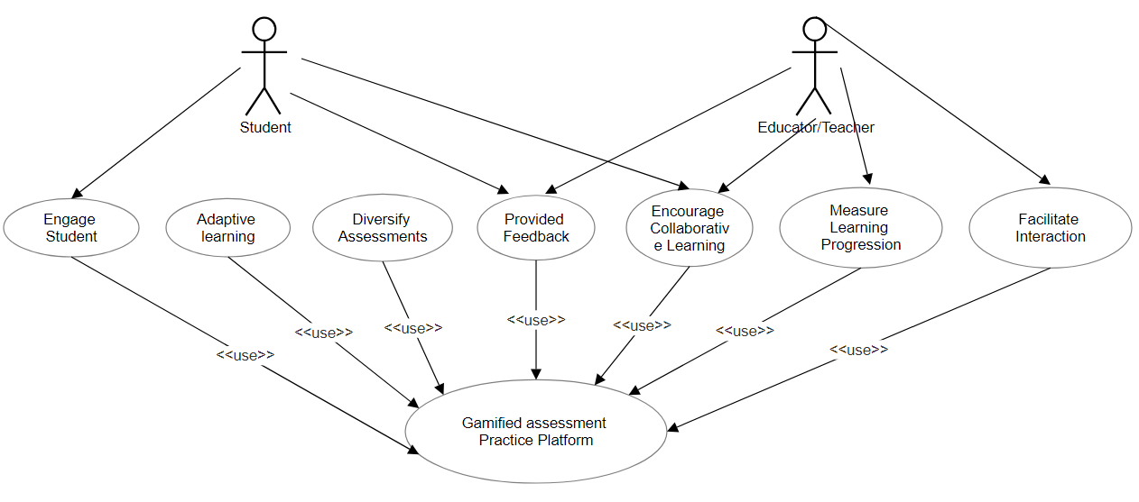
B. Use case description

- Engage Student:
  - Description: This use case represents the system's functionality to engage students through gamification elements, interactive scenarios, and dynamic challenges. It aims to capture and sustain the students' interest in assessment practices.
- Provide Adaptive Learning:
  - Description: The system adapts to individual student performance by dynamically adjusting the difficulty of questions. This use case ensures that students are appropriately challenged, fostering a deeper understanding of concepts and supporting continuous learning and improvement.
- Diversify Assessment Formats:
  - Description: This use case involves offering a diverse range of assessment formats, including scenario-based challenges, interactive simulations, and collaborative group activities. It prepares students for various assessment methodologies encountered in academic settings.
- Provide Feedback:
  - Description: The system provides real-time and dynamic feedback on both correct and incorrect responses. This use case helps students understand the reasoning behind correct answers and offers constructive guidance to enhance the learning process.
- Encourage Collaborative Learning:
  - Description: Through interactive challenges and group activities, this use case fosters a sense of community and collaboration among students. It promotes peer-to-peer learning, communication, and the exchange of ideas.
- Measure Learning Progression:
  - Description: The system tracks and analyses individual student performance over time. This use case provides educators with insights into the effectiveness of instructional methods and allows for the assessment of consistent improvement or challenges.
- Cultivate Growth Mindset:
  - Description: Beyond traditional assessments, this use case aims to instil a growth mindset among students. Through dynamic challenges, adaptive learning paths, and constructive feedback, it encourages students to view mistakes as opportunities for growth.
- Facilitate Interaction:
  - Description: This use case involves creating a platform for meaningful interaction between educators and students. It allows educators to offer personalized guidance, answer queries, and provide additional support based on individual student performance, fostering a supportive and collaborative learning environment.
These use cases collectively contribute to the overall objectives of the Gamified Assessment Practice Platform, ensuring an engaging, adaptive.

4.2 Non functional requirements

Non-functional requirements are aspects of a system that describe how it behaves, rather than what it does. Here are some non-functional requirements that might be relevant to the Gamified Assessment Practice Platform (GAPP) project:
- Performance:
  - Response Time: The system should respond to user interactions within X seconds to ensure a seamless and engaging experience.
  - Scalability: The platform should be able to handle a scalable number of users simultaneously without significant degradation in performance.
- Reliability:
  - Availability: The system should be available for use 99.9% of the time to ensure accessibility for students and educators.
  - Fault Tolerance: In the event of a system failure, the platform should have mechanisms in place to recover quickly and minimize downtime.
- Security:
  - Data Encryption: All sensitive user data, including personal information and assessment results, should be encrypted during transmission and storage.
  - Access Control: The system should implement role-based access control to ensure that only authorized users can access certain features and data.
- Usability:
  - User Interface: The user interface should be intuitive and user-friendly, catering to users with varying levels of technical proficiency.
  - Accessibility: The platform should be designed to be accessible to users with disabilities, complying with relevant accessibility standards.
- Compatibility:
  - Browser Compatibility: The platform should be compatible with major web browsers (Chrome, Firefox, Safari, Edge) to ensure a consistent user experience.
  - Device Compatibility: The system should be accessible and functional across various devices, including desktops, laptops, tablets, and smartphones.
- Scalability:
  - User Load: The system should be designed to accommodate a growing number of users, ensuring that performance remains optimal even during peak usage periods.
- Maintainability:
  - Code Maintainability: The codebase should be well-documented and adhere to coding standards, facilitating future maintenance and updates.
  - Modularity: The system should be designed with modular components, allowing for easier updates and enhancements.
- Interoperability:
  - Integration with Learning Management Systems (LMS): The platform should integrate seamlessly with popular learning management systems to streamline data exchange and user management.
- Data Management:
  - Backup and Recovery: Regular backups of user data should be performed, and the system should have a robust recovery plan in case of data loss.
- Legal and Compliance:
  - Data Privacy: The platform should comply with relevant data protection laws and ensure the privacy of user information.
  - Content Ownership: The system should have mechanisms to address copyright issues and ensure that all content is used appropriately.

4.3 Major Modules and their functionalities

The Gamified Assessment Practice Platform (GAPP) project can be organized into several major modules, each serving distinct functionalities to achieve the project's objectives. Here are the major modules and their respective functionalities:
- User Management Module:
  - User Registration: Allows students and educators to create accounts on the platform.
  - Profile Management: Enables users to update their profiles, including personal information and preferences.
  - Authentication: Manages user login and authentication processes to ensure secure access.
- Assessment Creation Module:
  - Question Bank Management: Facilitates the addition, editing, and deletion of questions in a centralized question bank.
  - Assessment Configuration: Allows educators to create assessments, configure parameters, and set up gamification elements.
  - Scenario-Based Challenges: Supports the creation of scenario-based challenges and interactive simulations for diverse assessment formats.
- Adaptive Learning Module:
  - Performance Tracking: Monitors individual student performance to adapt the difficulty level of questions based on their progress.
  - Adaptive Learning Paths: Generates personalized learning paths for students based on their strengths and weaknesses.
- Feedback and Analytics Module:
  - Real-time Feedback: Provides immediate feedback on assessment performance, highlighting correct answers and offering guidance on incorrect responses.
  - Performance Analytics: Generates comprehensive analytics and reports on individual and group performance for educators.
- Collaborative Learning Module:
  - Interactive Challenges: Facilitates collaborative and interactive challenges, allowing students to work together on assessments.
  - Group Activities: Supports collaborative group activities to enhance peer-to-peer learning and communication.
- Inclusivity Module:
  - Customizable Interfaces: Allows users to customize the platform interface based on their preferences.
  - Audio Support: Provides audio support for assessment content to assist users with different learning styles.
  - Language Options: Supports multiple language options to cater to a diverse user base.
- Growth Mindset Cultivation Module:
  - Dynamic Challenges: Introduces dynamic challenges that encourage students to view mistakes as opportunities for growth.
  - Constructive Feedback: Offers constructive and motivational feedback to promote a positive learning mindset.
- System Administration Module:
  - Security Management: Manages user access and ensures data privacy through authentication and authorization mechanisms.
  - Backup and Recovery: Implements regular backups and a robust recovery plan to prevent data loss.
- Integration Module:
  - Learning Management System (LMS) Integration: Integrates with popular LMS platforms to synchronize user data and assessment results.
These modules collectively contribute to creating a comprehensive and effective Gamified Assessment Practice Platform, ensuring an engaging, adaptive, and inclusive learning experience for students.

- SYSTEM ANALYSIS & DESIGN

5.1 SEQUENCE DIAGRAM

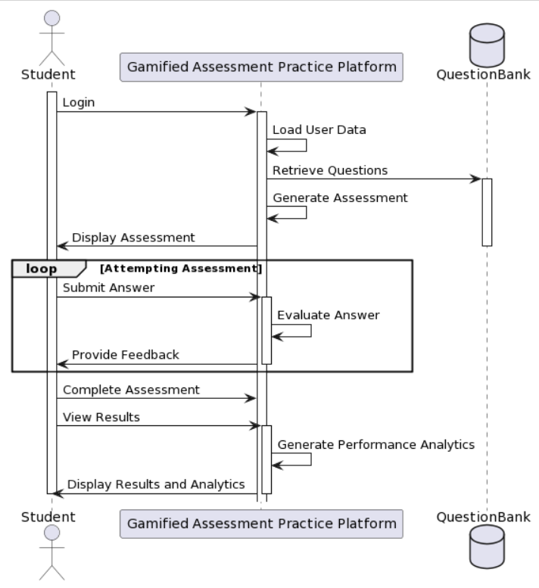

The interaction flow between a student (actor) and the Gamified Assessment Practice Platform (GAPP) system, including the Question Bank database. Let's break down the key components and the sequence of events:

1. Actor: Student
- Represents the user (student) who is interacting with the GAPP system.

2. Participant: Gamified Assessment Practice Platform (GAPP)
- Represents the GAPP system, responsible for managing the assessment process.

3. Database: QuestionBank
- Represents the Question Bank database, which stores questions used in assessments.

Sequence of Events:

- Login:
- The student initiates the interaction by logging in to the GAPP system.

- Load User Data:
- Upon login, the GAPP system activates and loads user-specific data.

- Retrieve Questions:
- The GAPP system retrieves questions from the QuestionBank database.

- Generate Assessment:
- Using the retrieved questions, the GAPP system generates an assessment for the student.

- Display Assessment:
- The generated assessment is displayed to the student.

- Attempting Assessment Loop:
- The student enters a loop for attempting the assessment.
- The student submits answers to questions.
- The GAPP system activates to evaluate each answer.
- Feedback on each answer is provided to the student.

- Complete Assessment:
- The student completes the assessment.

- View Results:
- The student views the results of the completed assessment.

- Generate Performance Analytics:
- The GAPP system generates performance analytics.

- Display Results and Analytics:
- Results and analytics are displayed to the student.

Activation and Deactivation:
- Activation and deactivation frames indicate the lifeline of each participant during the sequence of events.

Loops:
- The loop structure represents the iterative process of attempting and evaluating answers until the assessment is complete.

Activity diagram
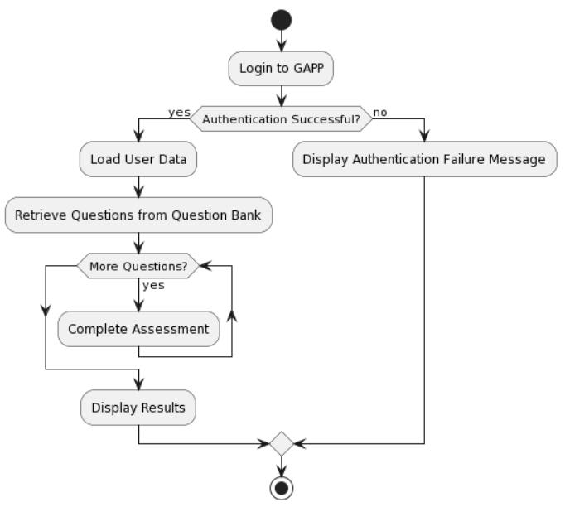
The process of a user interacting with the Gamified Assessment Practice Platform (GAPP). Let's break down the key components and flow:

1. User:
- Represents a user, typically a student or educator, interacting with the GAPP system.

2. Login:
- The process begins with the user logging in to the GAPP platform.

3. Authentication:
- The system checks whether the authentication is successful or not.

4. Load User Data:
- If authentication is successful, the system proceeds to load user-specific data, such as profiles and preferences.

5. Retrieve Questions from Question Bank:
- After loading user data, the system retrieves questions from the Question Bank, possibly based on the user's profile or preferences.

6. Assessment Process:
- The system initiates a loop to allow the user to complete multiple assessments as long as there are more questions to answer.
- Within the loop, the user completes assessments, possibly with varying questions or scenarios.

7. Display Results:
- After completing assessments, the system displays the results to the user.

8. Authentication Failure Message:
- If authentication fails, the system displays a message indicating authentication failure.

9. End:
- The process concludes, and the activity diagram ends.

Flow:
- The process starts with the user logging in.
- If authentication is successful, the system proceeds to load user data and retrieve questions for assessments.
- The user then engages in a loop to complete assessments.
- After completing assessments, the results are displayed.
- If authentication fails, an authentication failure message is displayed.

Key Decisions:
- The use of decision diamonds (diamond-shaped symbols) indicates points in the process where the system makes decisions based on conditions (authentication success or failure).
- The simplicity of this diagram makes it suitable for conveying the overall flow of user activities in a concise manner.

DATA FLOW DIAGRAM

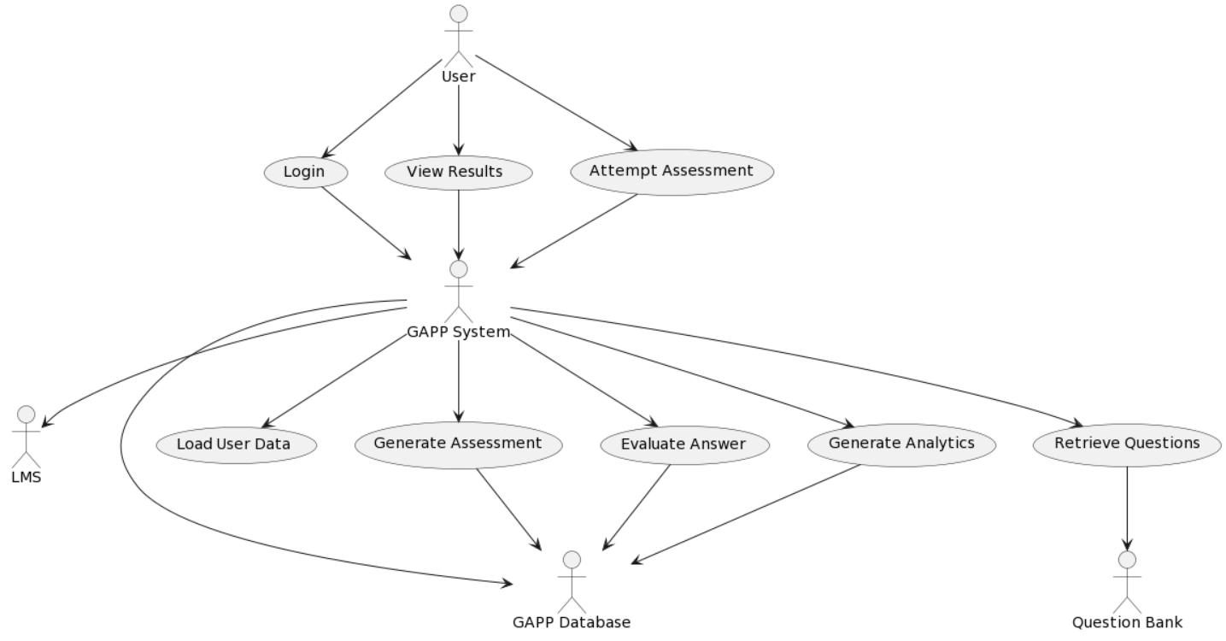

Data Flow Diagram
The various components in the Gamified Assessment Practice Platform (GAPP) project. Let's break down the key components and relationships:

1. User:
- Represents students and educators interacting with the system.

2. GAPP System:
- The core system responsible for managing user interactions, assessments, and analytics.
3. Question Bank (QB):
- Stores and provides questions for assessments.

4. Learning Management System (LMS):
- An external system that the GAPP platform interacts with, possibly for integration purposes.

5. GAPP Database (DB):
- Manages data related to user profiles, assessments, questions, and analytics.

Interactions:
- Users initiate three main actions: logging in, viewing results, and attempting assessments.
- Upon login, the GAPP system is responsible for handling the user's session and coordinating subsequent actions.
- The GAPP system interacts with the database (DB) to load user data, retrieve questions, generate assessments, evaluate answers, and generate analytics.
- The GAPP system also interacts with the Question Bank (QB) to retrieve questions and with the Learning Management System (LMS).
- The database (DB) is involved in storing and retrieving data related to questions, assessments, user profiles, and analytics.

Key Processes:
1. Login Process:
- User logs in.
- GAPP system loads user data.

2. View Results Process:
- User views assessment results.
- GAPP system retrieves and displays results.

3. Attempt Assessment Process:
- User attempts an assessment.
- GAPP system retrieves questions, generates the assessment, evaluates answers, and generates analytics.

4. Data Flows:
- Data flows between the User, GAPP System, Question Bank (QB), Learning Management System (LMS), and GAPP Database (DB) as the system handles user interactions, assessments, and analytics.

5. Dependencies:
- The GAPP system depends on the Question Bank (QB) for assessment content and the Learning Management System (LMS) for potential integration.

Timelines

September:
- Define Project Scope and Objectives
- Conduct Stakeholder Meetings
- Develop Project Plan and Schedule
- Set Up Project Repository

October:
- Complete Requirements Analysis
- Design System Architecture
- Create Wireframes and Prototypes

November:
- Begin Development of Core System Components
- Build Database Structure
- Initiate Integration with Question Bank and LMS
- Continue System Development
- Implement Assessment Generation and Evaluation Logic

December:
- Develop User Interface and User Experience
- Conduct Initial Testing of Core Features
- Complete Development of Major Features
January:
- Implement User Authentication and Authorization
- Implement Adaptive Learning and Analytics
- Conduct User Acceptance Testing (UAT)
- Address Feedback and Make Iterative Improvements

February:
- Finalize System Testing and Quality Assurance
- Prepare for System Deployment
- Conduct Training Sessions for Educators and Students
- Deploy Gamified Assessment Practice Platform
- Monitor System Performance and Gather User Feedback

Post-Deployment:
- Conduct Post-Implementation Review
- Address Any Post-Deployment Issues
- Plan for Future Enhancements and Updates

RESULTS / OUTPUTS & TESTING

7.1 All user interfaces and output screens

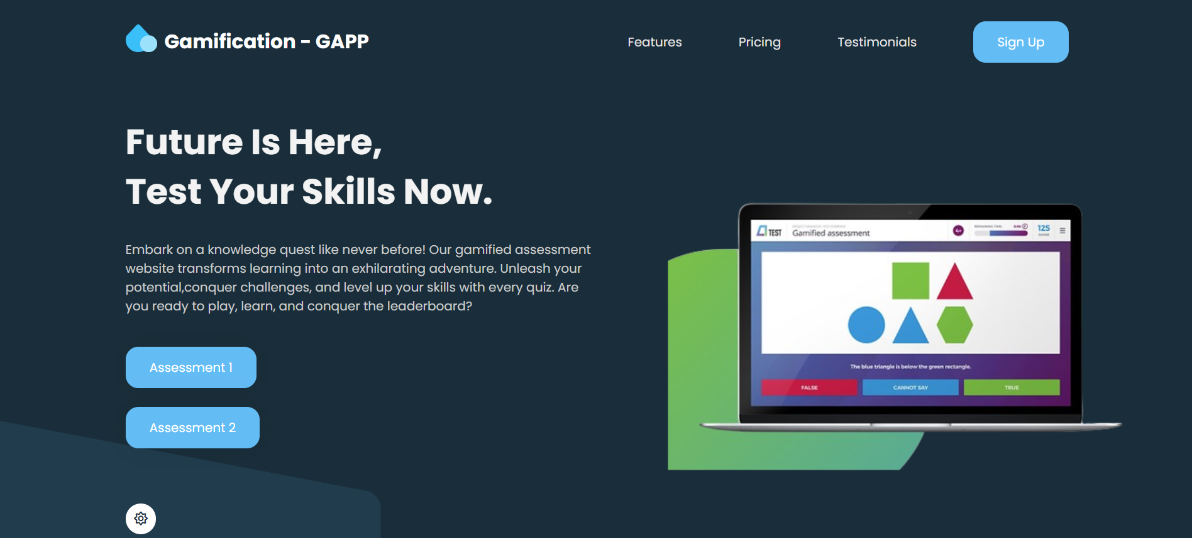

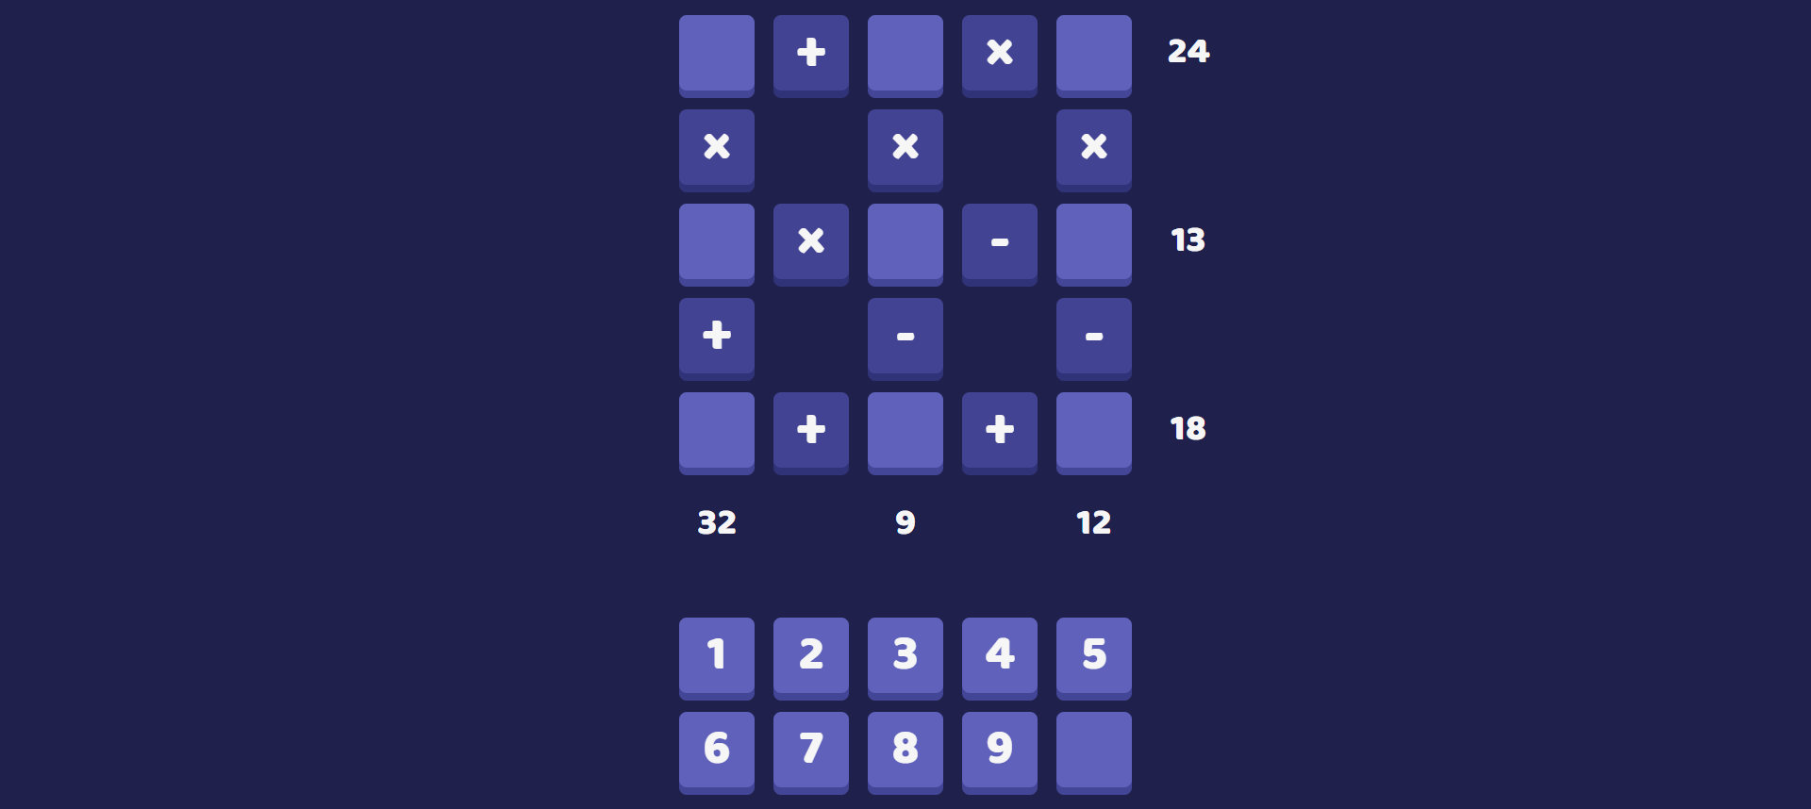

7.2 Layouts of web Pages and screens

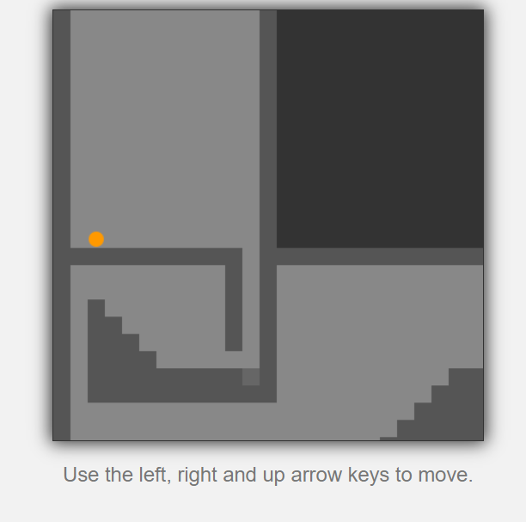


References

https://ietresearch.onlinelibrary.wiley.com/doi/full/10.1049/iet-sen.2018.5084

https://link.springer.com/article/10.1007/s10648-019-09498-w

https://dev.to/gscode/10-best-of-javascript-games-3mjj

https://essay.utwente.nl/80459/1/Grobben_MA_BMS.pdf

https://scholarworks.calstate.edu/downloads/zc77sr989?locale=zh

https://getbootstrap.com/

